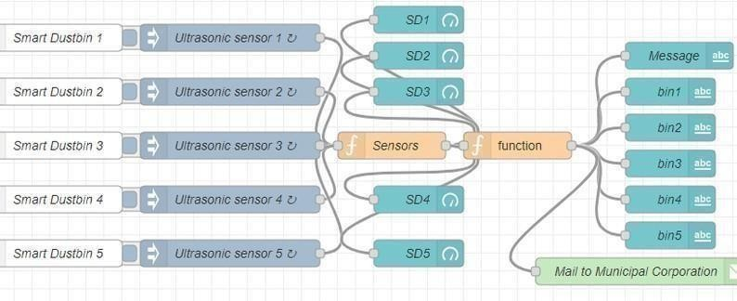Develop A Web Application Using Node-RED Service

|  |  |
| --- | --- |
| Date | 21 November2022 |
| Team ID | PNT2022TMID06240 |
| Project Name | SMART WASTE MANAGEMENT SYSTEM FOR METROPOLITIAN CITIES |
| Maximum Marks | 4 Marks |